**What is the purpose of this API?**

Company API lets you lookup company data via a domain name for example google.com, flipkart.com etc.

**Authentication :**

This API works on HTTP Basic Auth authentication. API key is used as the basic auth username with no password

This API exposes 2 end points :

1. /v2/companies/find?domain=domain

Domain= Domain Name of company

This is a HTTP Get request.

The supported parameters are:

Domain : **string (required)**

webhook_url : **string**

company_name : **string**

linkedin : **string**

twitter : **string**

facebook : **string**

**RESPONSE TYPES**

| **Code** | **Description** |
| --- | --- |
| 200 | Successful lookup, company encoded in the response body. |
| 202 | Asynchronously looking up the company. |
| 404 | Company not found. |
| 422 | Domain name is invalid. |

**Sample Response looks like below :**

{

"id": "3f5d6a4e-c284-4f78-bfdf-7669b45af907",

"name": "Uber",

"legalName": "Uber Technologies, Inc.",

"domain": "uber.com",

"domainAliases":

[ "uber.org", "

ubercab.com" ],

"site": {

"phoneNumbers": [],

"emailAddresses":

[ "domains@uber.com" ]

},

"category":

{

"sector": "Information Technology",

"industryGroup": "Software & Services",

"industry": "Internet Software & Services",

"subIndustry": "Internet Software & Services",

"sicCode": "47",

"naicsCode": "51"

},

"tags":

[ "Technology",

"Marketplace",

"Mobile",

"B2C",

"Ground Transportation",

"Transportation",

"Internet" ],

"description": "Get a taxi, private car or rideshare from your mobile phone. Uber connects you with a driver in minutes. Use our app in cities around the world.",

"foundedYear": 2009,

"location": "1455 Market St, San Francisco, CA 94103, USA",

"timeZone": "America/Los_Angeles",

"utcOffset": -7, "

geo": {

"streetNumber": "1455",

"streetName": "Market Street",

"subPremise": null,

"city": "San Francisco",

"postalCode": "94103",

"state": "California",

"stateCode": "CA",

"country": "United States",

"countryCode": "US",

"lat": 37.7752315,

"lng": -122.4175278

},

"logo": "https://logo.clearbit.com/uber.com",

"facebook":

{ "handle": "uber" },

"linkedin":

{ "handle": "company/uber-com" },

"twitter":

{ "handle": "Uber",

"id": "19103481",

"bio": "Evolving the way the world moves by seamlessly connecting riders to drivers through our app. Question, concern, or praise? Tweet at @Uber_Support.",

"followers": 570351,

"following": 377,

"location": "Global",

"site": "http://t.co/11eIV5LX3Z",

"avatar": <https://pbs.twimg.com/profile_images/697242369154940928/p9jxYqy5_normal.png>

},

"crunchbase":

{ "handle": "organization/uber" },

"emailProvider": false,

"type": "private",

"ticker": null,

"identifiers":

{ "usEIN": "452647441" },

"phone": null,

"indexedAt": "2016-11-07T00:00:00.000Z",

"metrics":

{ "alexaUsRank": 544,

"alexaGlobalRank": 943,

"employees": 20313,

"employeesRange": "10k-50k",

"marketCap": null,

"raised": 10610000000,

"annualRevenue": null,

"estimatedAnnualRevenue":

"$1B-$10B",

"fiscalYearEnd": 12

},

"tech": [ "optimizely", "tealium", "atlassian_confluence", "workday", "talend", "oracle_peoplesoft", "salesforce", "teradata", "apache_kafka", "aws_dynamodb", "grafana", "factset", "dropbox" ],

"techCategories": [ "analytics", "advertising", "productivity", "human_capital_management", "data_management", "business_management", "crm", "monitoring" ],

"parent": { "domain": null }, "

ultimateParent": { "domain": null

}

}

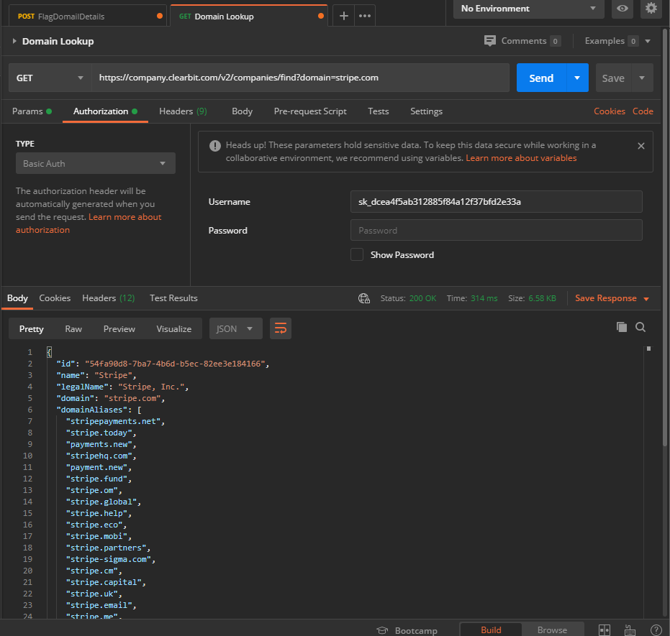

1. /v2/companies/flag?domain=domain

Domain = domain name

This is a Post request

Below are the Request body parameters :

| **param** | **Description** |
| --- | --- |
| name | **string***(optional)* Name of company |
| tags | **array**List of market categories the company is involved in |
| description | **string**Description of the company |
| raised | **integer**Total amount raised |
| location | **string**Address of company |
| facebook_handle | **string***(optional)* Facebook ID or screen name |
| twitter_handle | **string***(optional)* Twitter screen name |
| linkedin_handle | **string***(optional)* LinkedIn URL (i.e. /pub/alex-maccaw/78/929/ab5) |
| crunchbase_handle | **string**Crunchbase handle |
| employees | **integer**Amount of employees |
| logo | **string**SRC of company logo |
| email_provider | **boolean**is the domain associated with a free email provider (i.e. Gmail)? |

type **string**

**Below are the Response Types :**

200 – Successful received, We will look into the issue

400 – Company not found

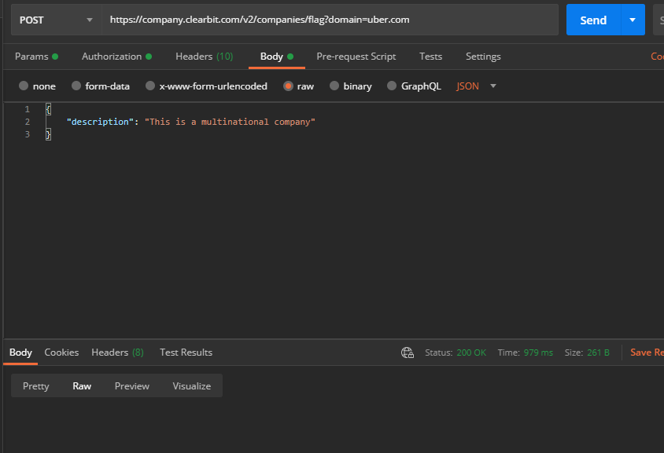

Test Strategy

1. Testing Approach

* Functional testing
* Automation testing
* Automated test data generation

1. Tools :

* Postman/Swagger for Functional testing
* RestAssured for automation testing

1. API Test Actions
   * Verify Authorisation mechanism
   * Verify response code
   * Verify response Payload
   * Verify basic performance
2. Test scenarios

* Basic Positive tests
* Extended Possitive tests with optional parameters
* Negative testing
* Destructive testing